**Experiment No : 07**

**Title : Write a Python program to demonstrate the use of if and if else.**

**Problem statements:**

**a**.Check if given number is even or odd.

b. Display grade of student depending on percentage.

percentage>=90: Excellent

percentage>=80 and <90: First class

percentage>=60 and <80: Second class

percentage>=40 and <60: Pass Class

percentage< 40: Fail

**Theory :**

**If-Else Statement :**

If the suite of an if clause consists only of a single line, it may go on the same line as the header statement.

An else statement can be combined with an if statement. An else statement contains the block of code that executes if the conditional expression in the if statement resolves to 0 or a FALSE value.

The *else* statement is an optional statement and there could be at most only one else statement following if.

Syntax

if expression:

statement(s)

else:

statement(s)

**Code :**

percentage=*int*(input('Enter Percentage : '))

if percentage>=90:

    print('Excellent')

elif (percentage>=80 and percentage<90):

    print('First class')

elif (percentage>=60 and percentage<80):

    print('Second class')

elif (percentage>=40 and percentage<60):

    print('Pass Class')

elif (percentage< 40):

    print('Fail')

**output :**

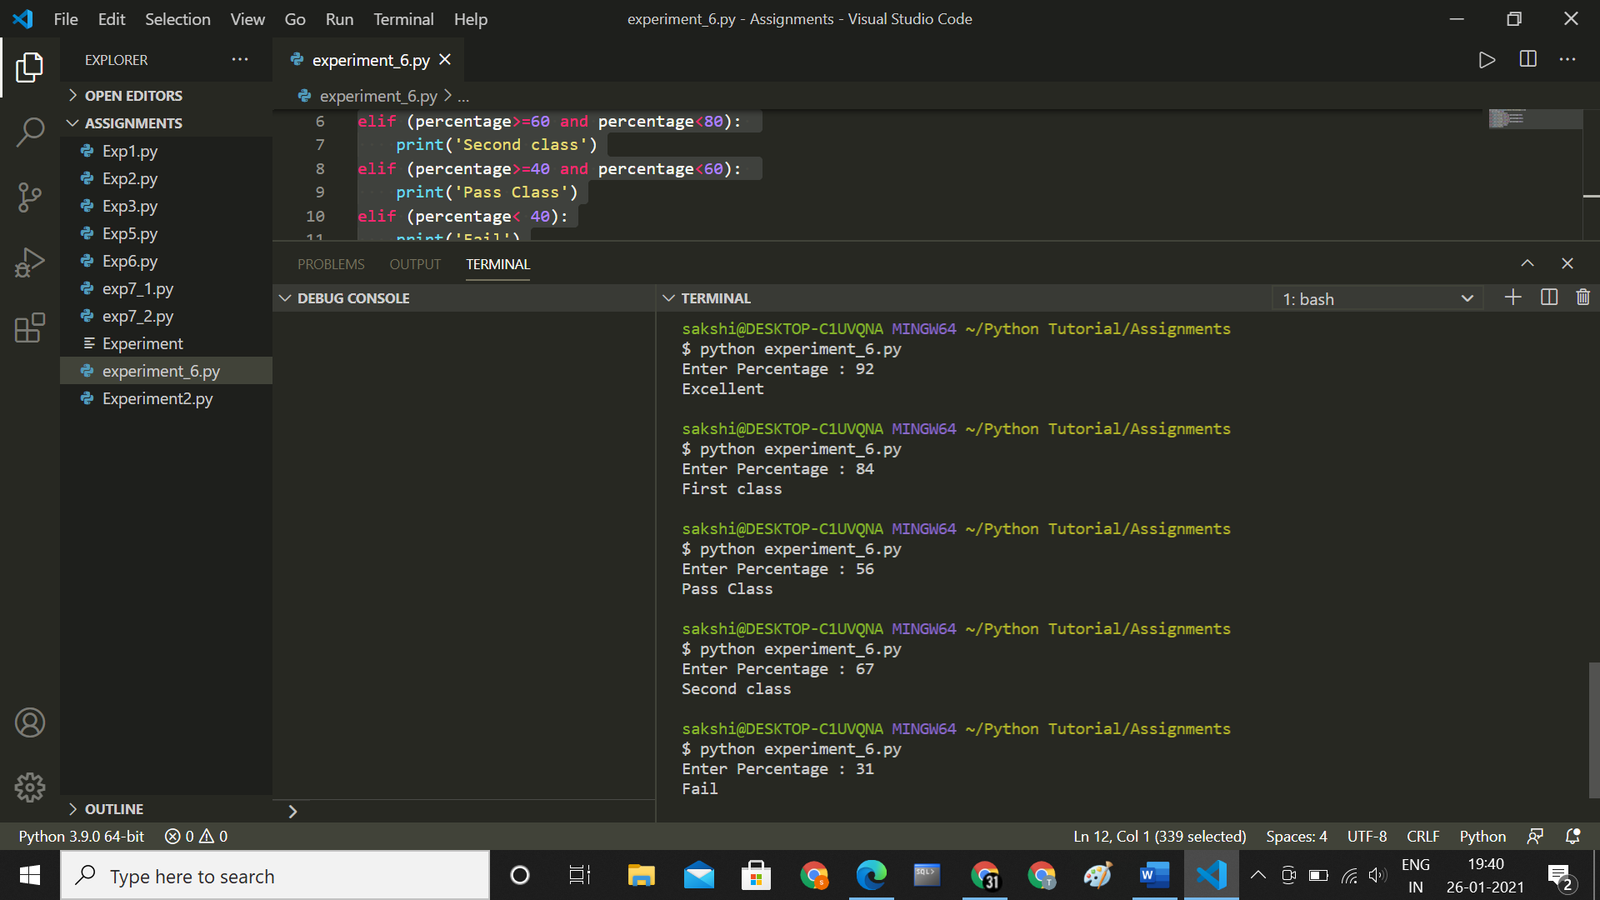

**Conclusion :**

**Thus we have understood how to Write Python program to demonstrate the use of if and if else.**